# **Oracle Cloud Day- Application Development Hands-On Workshop**

## **DevOps on Oracle Paas:**

## Lab Overview

In this lab you’ll learn how to leverage Oracle Developer Cloud Service to help a development team manage their agile development process and automate their DevOps cycle on Oracle Cloud infrastructure (Java Cloud Service).

How to create demo environment with all needed components:   
(Click Ctrl+links below)

* [Setup Developer Cloud Service Instance](https://docs.oracle.com/en/cloud/paas/developer-cloud/csdcs/service-setup.html#GUID-8EE9FC19-70A0-4508-A6B1-FB8425C13A91)
* [Create Java Cloud Service](https://www.youtube.com/watch?time_continue=27&v=1X2O5i-NTjw)

# Managing Projects with Developer Cloud Service

## Creating a DevCS Project

In this lab you’ll create a DevCS project for your team and learn about some of the basic tasks of a project administrator.

### Creating a Project

1. Using your cloud user – login into your cloud account.
2. In my services dashboard locate Developer (if not visible click customize dashboard and make sure developer is in show mode).
3. Open the service console.
4. Create a new project
5. Choose the following options in the dialog

* Private project
* Initial Repository
* Confluence syntax for your wiki

[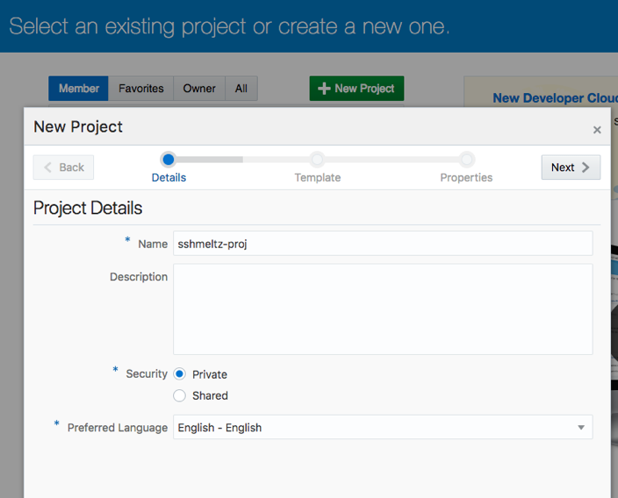](https://github.com/PrasannaShasthri/eca-draft/blob/master/tutorials/DevcsImages/Picture1.png)

[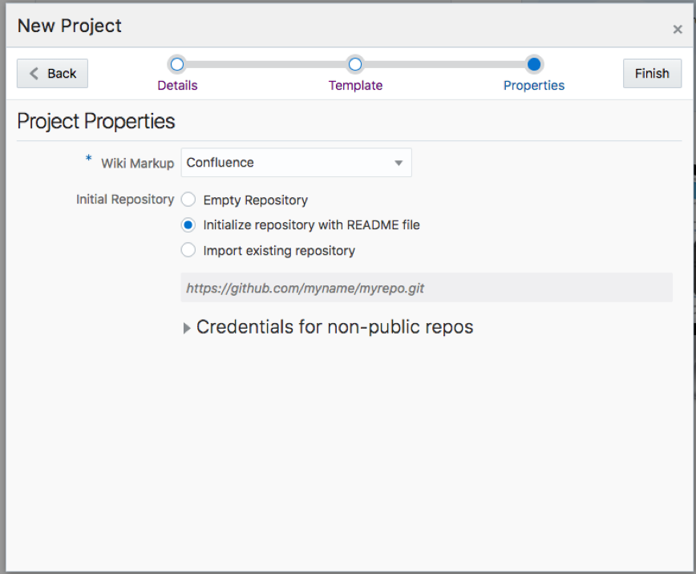](https://github.com/PrasannaShasthri/eca-draft/blob/master/tutorials/DevcsImages/Picture2.png)

1. Click Finish to create your project. Once the project is created you’ll be taken into the project’s home page.

[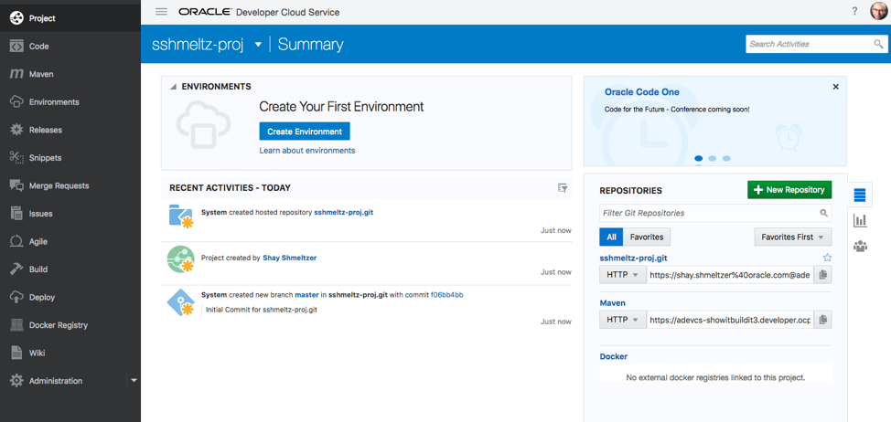](https://github.com/PrasannaShasthri/eca-draft/blob/master/tutorials/DevcsImages/Picture3.png)

# Adding a Git Repository

A DevCS Project can have multiple git repositories. We are going to add a new repostiroy copying the content of an existing repository on GitHub.

1. In the left menu choose Administration and then the Repositories section
2. Click to add a New Hosted Repository
3. Name the repository and choose to import existing repository –

use this URL: <https://github.com/saiyam1814/oraclecloudday>

Click Create.

[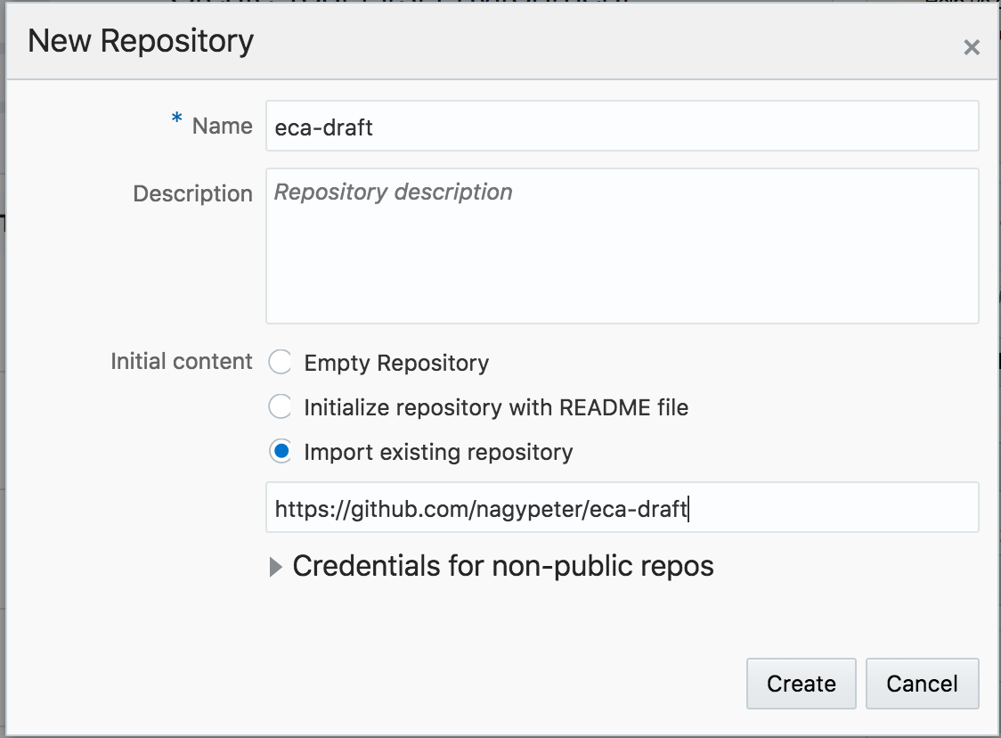](https://github.com/PrasannaShasthri/eca-draft/blob/master/tutorials/DevcsImages/Picture7.png)

1. In the left menu choose the Code section and you'll see all the code you need for the next labs in your project.
2. You can click on any of the files to see the content and even edit it directly from your browser.
3. From the web interface you can also branch the code when needed.

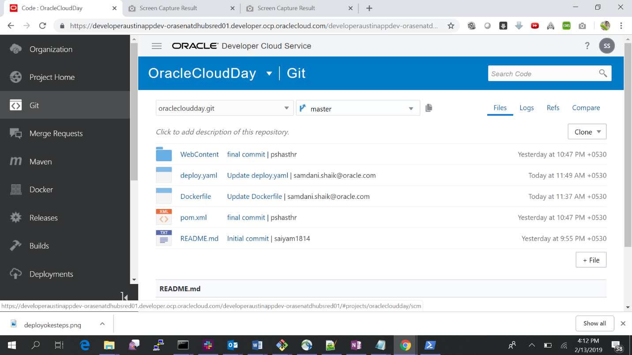

# Creating build job in Developer Cloud Service to build Java Application

1. Open your DevCS project and from the left navbar choose Build. Click +New Job to create a build job. The build job configuration opens. On the first Source Control tab click Add Source Control and select Git. From the Repository dropdown list select the source code repository.

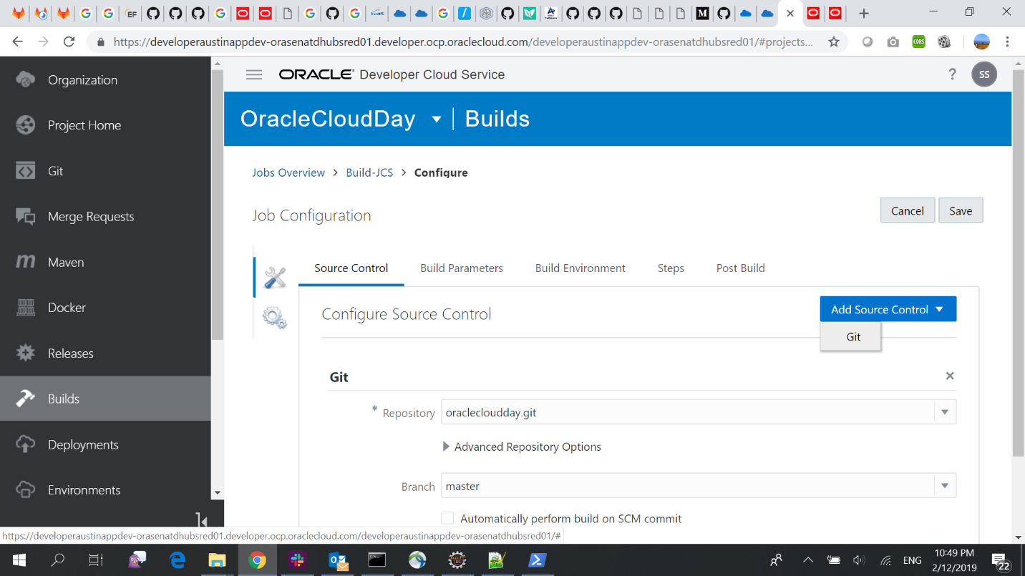

1. Define the build steps in “Steps”. Add your first step by clicking on Add Maven.

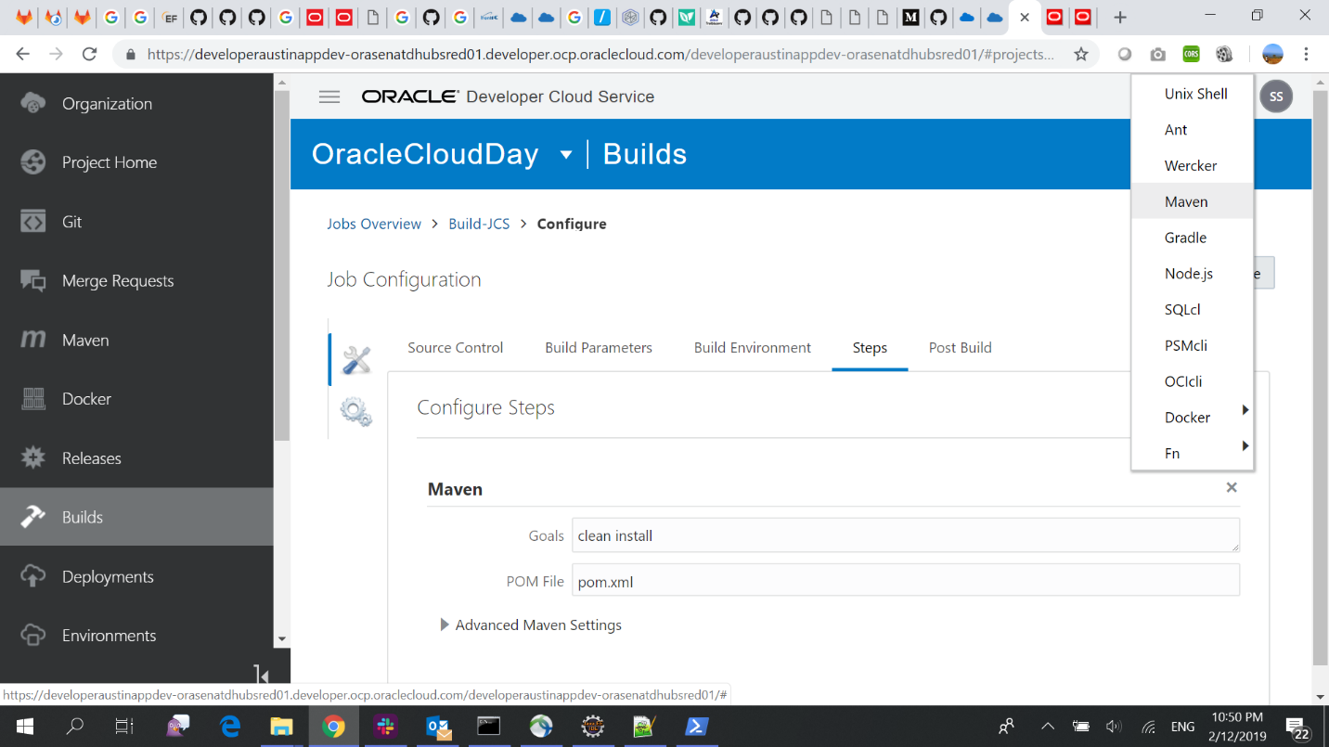

1. Save and build the job.

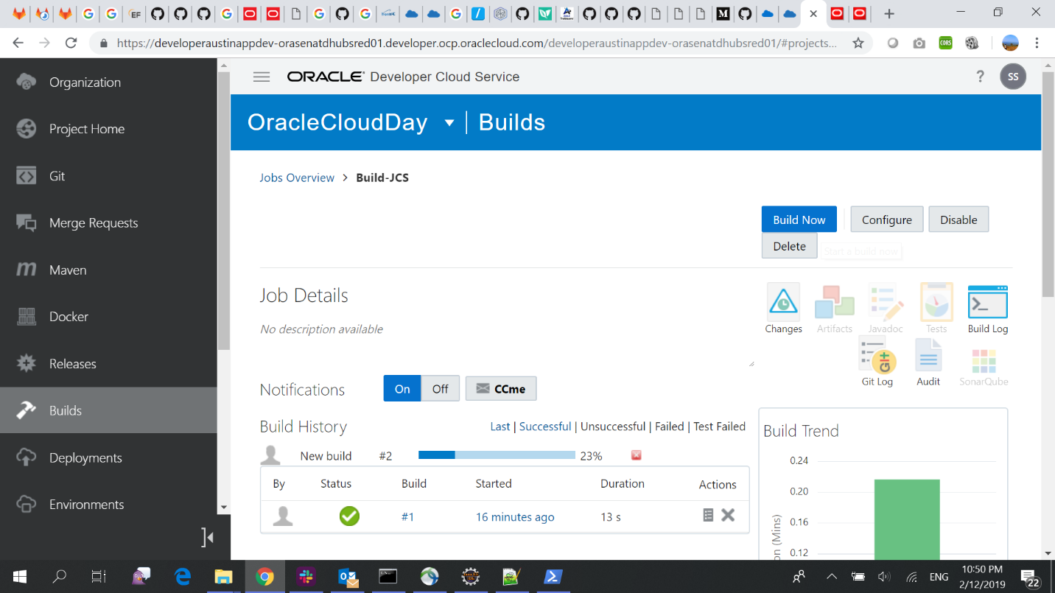

# Creating deployment in Developer Cloud Service to deploy Java Application onto Java Cloud Service

1. Open your DevCS project and from the left navbar choose Deployments. Click +Create Configuration to create a configuration plan for deploying your application to JCS instance.

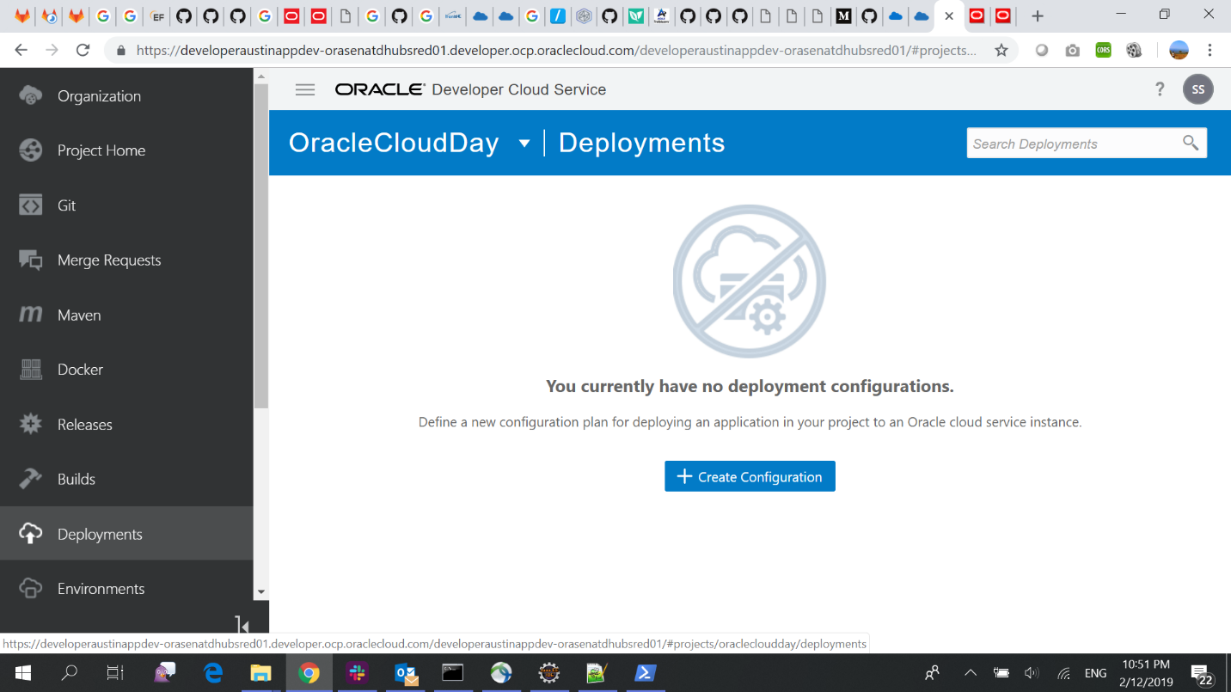

1. Give the Deployment Name, add new Deployment Target as Java cloud service, select the success build job and artifacts generated.

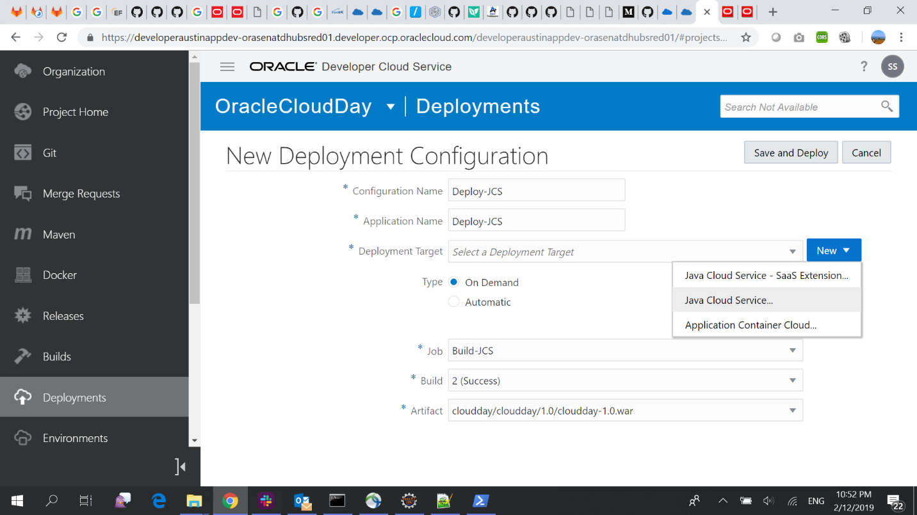

1. Select the weblogic server version, give the host IP, https port and weblogic credentials and click Find Targets.

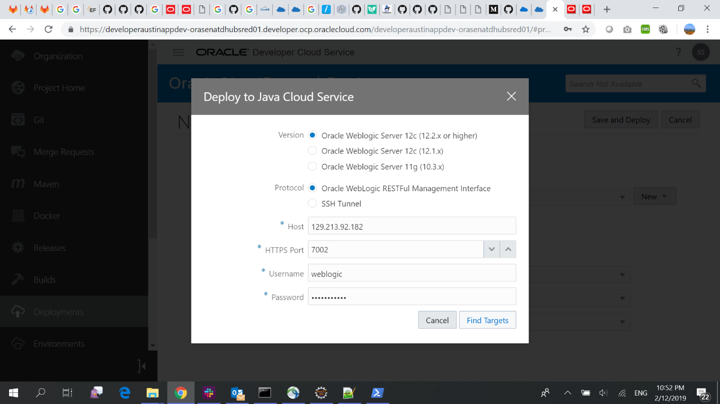

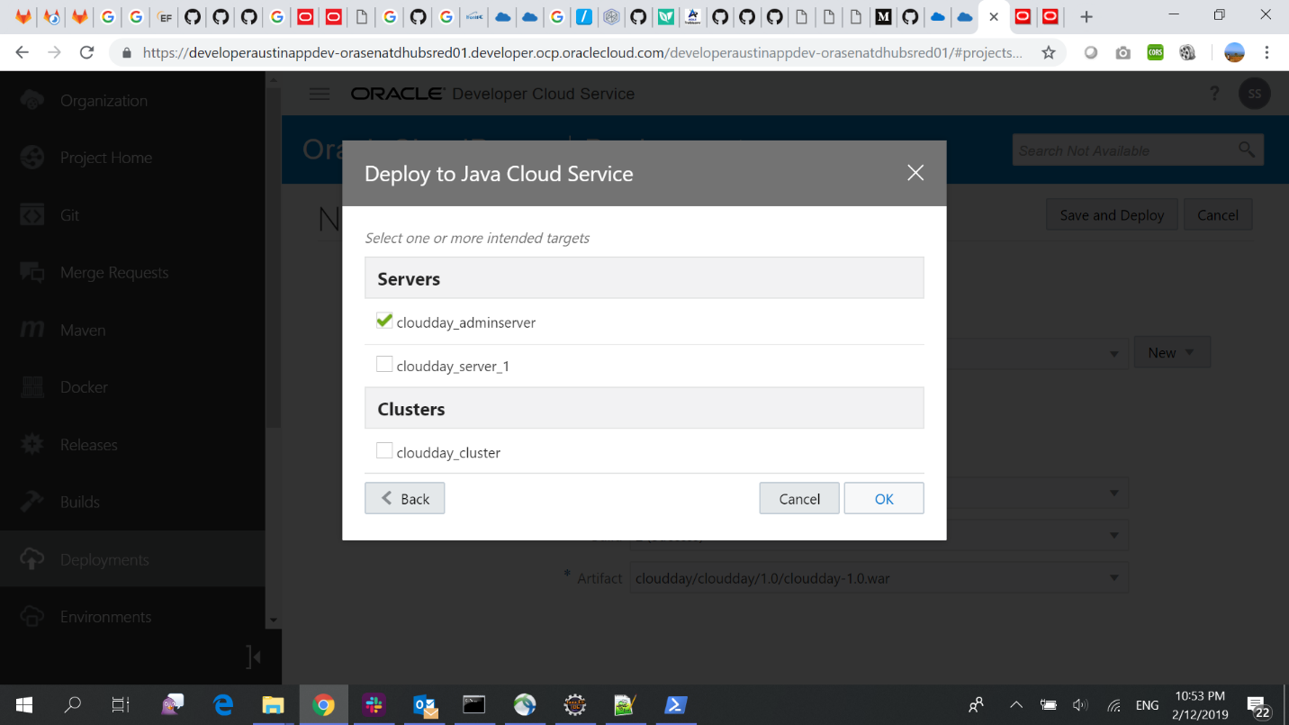

1. Click Save and Deploy. The deployment will start and application will be up and running in your JCS instance.

